`
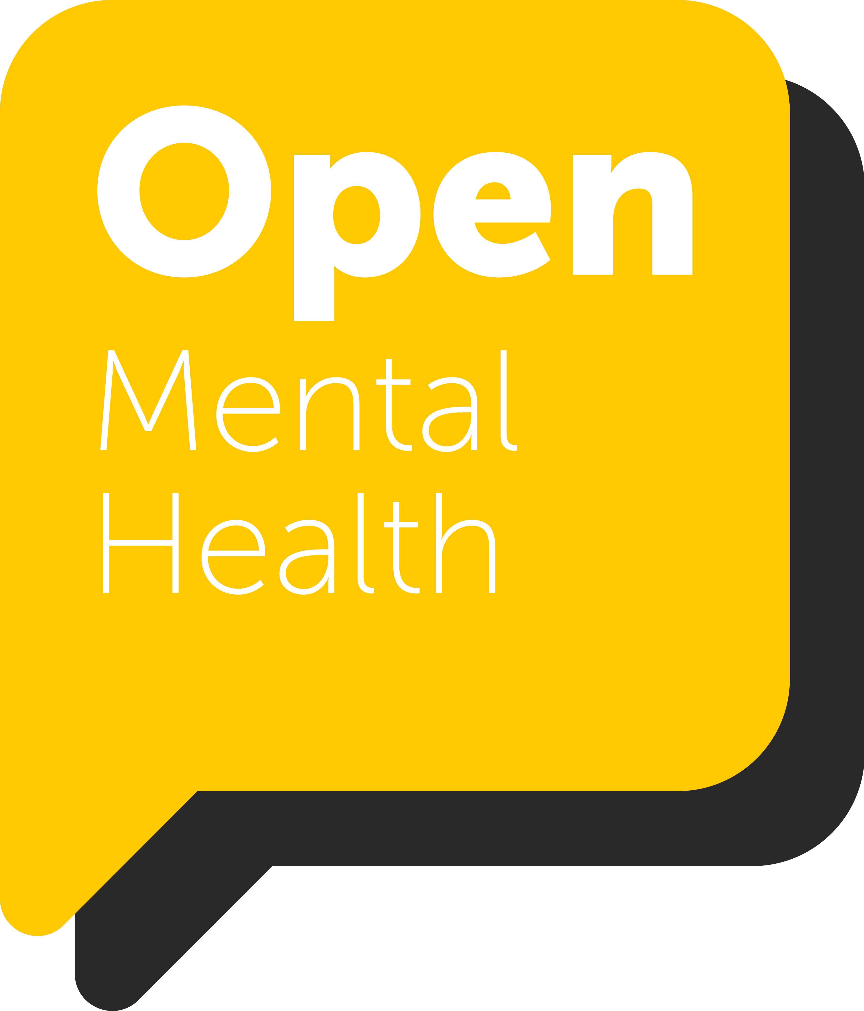
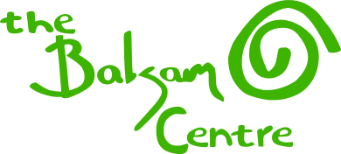

South Somerset
Lead Locality Co-ordinator
OPEN MENTAL HEALTH
JOB DESCRIPTION
Open Mental Health (OMH) is a Somerset Alliance of local Voluntary Community and Social Enterprise (VCSE) organisations and the NHS, in conjunction with Somerset County Council.

Our shared ambition is to ensure that people living with mental health problems get the right support at the right time. Working together, we support people to live a full life, by enabling access to specialist mental health services, housing support, debt and employment advice, volunteering opportunities, community activities and physical exercise, to help support and improve people’s wellbeing and quality of life.

The Locality Co-ordinator has a key role in implementing the effective delivery of Open Mental Health work across South Somerset.

Our model makes use of social and therapeutic interventions that are not clinical in nature but are undertaken with the benefit of a clinical background, experience and training.

The Locality Co-ordinator role provides a fantastic opportunity to work in Open Mental Health in Somerset and help create the new countywide model of Recovery and Wellbeing.

Job Title: | Lead Locality Co-ordinator – South Somerset
Responsible to: | Chief Executive Officer of the Balsam Centre
Base: | Location in South Somerset
Term: | Fixed term contract to end of March 2024
Working Hours: | 15 hrs a week
Salary | Up to £27,000 pro rata dependent on experience
Annual Leave: | 28 days pro rata
Probationary Period: | 3 months
Notice: | 2 months
Expenses: | Mileage allowance for occasional car use
JOB PURPOSE:
The purpose of the job is to provide high level administrative support to assist the Locality Operations Manager and the Recovery and Wellbeing Worker team in the effective delivery of a range of VCSE services and activities that support people’s mental health across South Somerset, in partnership with Somerset NHS Foundation Trust.
It requires the establishment of strong working relationships with the wider ‘eco-system’ of community and Voluntary Sector support in the District. The post holder should have a good understanding of the determinants of mental health, together with a knowledge of the geography/demography and health and social infrastructure of South Somerset in order to assist in the development of activities and services for OMH.
The Main Responsibilities of the Post Holder are to:
- Provide specialist administrative support to the Balsam Centre’s OPEN Mental Health Team for South Somerset.
- Take ownership of the South Somerset locality inbox, recording, collating and actioning messages
- Record, collate and action information received through dedicated OMH inbox/es
- Be responsible for following up, actioning and completing introductions between beneficiaries and OMH partners
- Attend MDT Interface meetings and present a beneficiary list for discussion
- Maintain accurate up to date beneficiary information on a purpose built database
- Convene regular Locality meetings and take meeting notes
- Support the Operations Manager in developing the ‘Locality Offer’ workstream
- Help facilitate practical and operational partnerships with smaller charities and community organisations of the eco-system
- Work constructively with other Locality Co-ordinators to develop the OMH model
- Share information according to agreed protocols, always working within the boundaries of confidentiality and Data Security and Protection
- Report regularly to the Operations Manager and participate in Balsam/Open/Team meetings
- Represent smaller charities of Open Mental Health on the Communications Steering Group
- Take on any other duties which may reasonably be requested to further the aims of Open Mental Health or The Balsam Centre.

PERSON SPECIFICATION
The job will involve expertise in the use of a full range of communication and administrative skills.
The post holder will have a personal commitment to making a positive difference in improving people’s mental and physical health and wellbeing.
The post holder will need to work flexibly. Working from home will be possible during Coronavirus restrictions.
ESSENTIAL:
- An understanding of holistic mental health principles and practice.
- A working knowledge of the geography of South Somerset
- An understanding of Health, Social, Statutory and Voluntary Sector structures
- An understanding and experience of multi-disciplinary team working
- A relevant qualification and experience in e.g. Communication or Administration
- Knowledge of safeguarding policies and procedures relating to adults, children and young people
- Excellent people and communication skills
- Excellent time management and flexibility
- A responsive, resourceful and pro-active approach
- A personal commitment to making a positive difference to the health and wellbeing of beneficiaries
- Ability to develop and maintain effective working partnerships at all levels
- An understanding of key concepts such as co-production, peer support, inclusion, recovery and wellbeing
- Knowledge and understanding of relevant health, safety, legal and ethical frameworks
- Ability to function effectively both independently and as a member of the team
- Confidence and humour
- Good IT skills including CRM, database use, Microsoft applications e.g. Teams and One Note
- A clean and current driving licence and access to a vehicle
DESIRABLE
- Relevant specialist skills, interests or knowledge
- A knowledge and understanding of the challenges of life in a rural community

