BOOKS:

Mental Health Journal for Men: Creative Prompts, Practices, and Exercises to Bolster Wellness Paperback – 4 Aug. 2020
by Ryan Howes (Author)

https://www.amazon.co.uk/Mental-Health-Journal-Men-Practices/dp/1647396255/ref=sr_1_1?adgrpid=107404667447&dchild=1&gclid=CjwKCAjw0qOIBhBhEiwAyvVcf2WEmX5mlf0JcllqH1cjUknRDNUfTy7UebKVMTIQiAvUlcpTpErbrxoCQpQQAvD_BwE&hvadid=445963430774&hvdev=c&hvlocphy=9045345&hvnetw=g&hvqmt=e&hvrand=13242499832230008205&hvtargid=kwd-825110760456&hydadcr=13716_1825022&keywords=mens+mental+health+books&qid=1627986441&sr=8-1
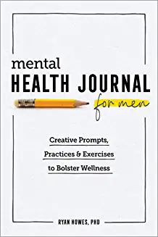

Man Down: A Guide for Men on Mental Health Paperback – 12 Mar. 2020
by Charlie Hoare (Author)

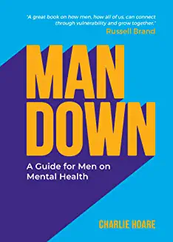

https://www.amazon.co.uk/gp/slredirect/picassoRedirect.html/ref=pa_sp_atf_aps_sr_pg1_1?ie=UTF8&adId=A0911187KPXGAEDH0R4O&url=%2FMan-Down-Guide-Mental-Health%2Fdp%2F1787832503%2Fref%3Dsr_1_2_sspa%3Fadgrpid%3D107404667447%26dchild%3D1%26gclid%3DCjwKCAjw0qOIBhBhEiwAyvVcf2WEmX5mlf0JcllqH1cjUknRDNUfTy7UebKVMTIQiAvUlcpTpErbrxoCQpQQAvD_BwE%26hvadid%3D445963430774%26hvdev%3Dc%26hvlocphy%3D9045345%26hvnetw%3Dg%26hvqmt%3De%26hvrand%3D13242499832230008205%26hvtargid%3Dkwd-825110760456%26hydadcr%3D13716_1825022%26keywords%3Dmens%2Bmental%2Bhealth%2Bbooks%26qid%3D1627986585%26sr%3D8-2-spons%26psc%3D1&qualifier=1627986585&id=269623691510134&widgetName=sp_atf

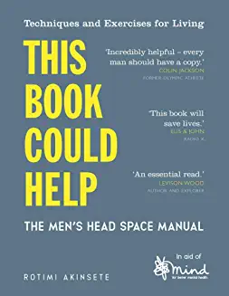

This Book Could Help: The Men's Head Space Manual – Techniques and Exercises for Living (Wellbeing Guides)
by MIND and Rotimi Akinsete | 2 May 2019

https://www.amazon.co.uk/This-Book-Could-Help-Techniques/dp/1789291313/ref=sr_1_6?adgrpid=107404667447&dchild=1&gclid=CjwKCAjw0qOIBhBhEiwAyvVcf2WEmX5mlf0JcllqH1cjUknRDNUfTy7UebKVMTIQiAvUlcpTpErbrxoCQpQQAvD_BwE&hvadid=445963430774&hvdev=c&hvlocphy=9045345&hvnetw=g&hvqmt=e&hvrand=13242499832230008205&hvtargid=kwd-825110760456&hydadcr=13716_1825022&keywords=mens+mental+health+books&qid=1627986585&sr=8-6

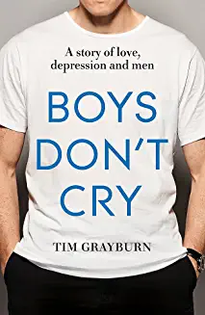

Boys Don't Cry: Why I hid my depression and why men need to talk about their mental health
by Tim Grayburn | 5 Apr 2018
https://www.amazon.co.uk/Boys-Dont-Cry-depression-mental/dp/1473636930/ref=sr_1_10?adgrpid=107404667447&dchild=1&gclid=CjwKCAjw0qOIBhBhEiwAyvVcf2WEmX5mlf0JcllqH1cjUknRDNUfTy7UebKVMTIQiAvUlcpTpErbrxoCQpQQAvD_BwE&hvadid=445963430774&hvdev=c&hvlocphy=9045345&hvnetw=g&hvqmt=e&hvrand=13242499832230008205&hvtargid=kwd-825110760456&hydadcr=13716_1825022&keywords=mens+mental+health+books&qid=1627986585&sr=8-10

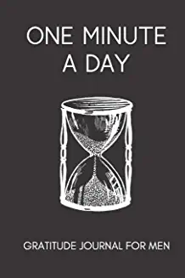

One Minute a Day Gratitude Journal for Men: Simple Daily Gratitude Notebook | Helps With Motivation, Productivity, Mental Health, Mindfulness and Positivity (Mindfulness for Men)
by Mindful Magic Journals | 13 Oct 2019

https://www.amazon.co.uk/One-Minute-Day-Gratitude-Journal/dp/1699643520/ref=sr_1_13?adgrpid=107404667447&dchild=1&gclid=CjwKCAjw0qOIBhBhEiwAyvVcf2WEmX5mlf0JcllqH1cjUknRDNUfTy7UebKVMTIQiAvUlcpTpErbrxoCQpQQAvD_BwE&hvadid=445963430774&hvdev=c&hvlocphy=9045345&hvnetw=g&hvqmt=e&hvrand=13242499832230008205&hvtargid=kwd-825110760456&hydadcr=13716_1825022&keywords=mens+mental+health+books&qid=1627986585&sr=8-13

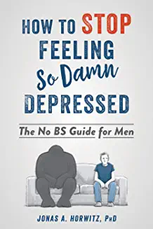

Stop Feeling So Damn Depressed: The No BS Guide for Men
by Jonas A Horwitz | 31 Jan 2019

https://www.amazon.co.uk/Stop-Feeling-So-Damn-Depressed/dp/1684032113/ref=sr_1_19?adgrpid=107404667447&dchild=1&gclid=CjwKCAjw0qOIBhBhEiwAyvVcf2WEmX5mlf0JcllqH1cjUknRDNUfTy7UebKVMTIQiAvUlcpTpErbrxoCQpQQAvD_BwE&hvadid=445963430774&hvdev=c&hvlocphy=9045345&hvnetw=g&hvqmt=e&hvrand=13242499832230008205&hvtargid=kwd-825110760456&hydadcr=13716_1825022&keywords=mens+mental+health+books&qid=1627986585&sr=8-19

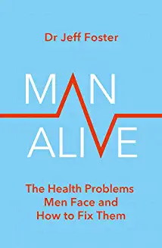

Man Alive: The health problems men face and how to fix them
by Dr Jeff Foster | 17 Jun 2021

https://www.amazon.co.uk/Man-Alive-health-problems-face/dp/0349427852/ref=sr_1_20?adgrpid=107404667447&dchild=1&gclid=CjwKCAjw0qOIBhBhEiwAyvVcf2WEmX5mlf0JcllqH1cjUknRDNUfTy7UebKVMTIQiAvUlcpTpErbrxoCQpQQAvD_BwE&hvadid=445963430774&hvdev=c&hvlocphy=9045345&hvnetw=g&hvqmt=e&hvrand=13242499832230008205&hvtargid=kwd-825110760456&hydadcr=13716_1825022&keywords=mens+mental+health+books&qid=1627986585&sr=8-20

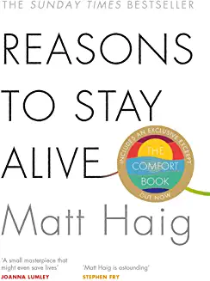

Reasons to Stay Alive
by Matt Haig | 5 Mar 2015

https://www.amazon.co.uk/Reasons-Stay-Alive-Matt-Haig-ebook/dp/B00N7KZLSG/ref=sr_1_1?crid=3BNBM0F7WSDHY&dchild=1&keywords=reasons+to+stay+alive+matt+haig&qid=1627987857&sprefix=REASONS+TO+STAY+%2Caps%2C175&sr=8-1

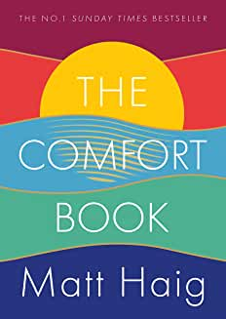

The Comfort Book: The instant No.1 Sunday Times Bestseller
by Matt Haig | 6 Jul 2021
https://www.amazon.co.uk/Comfort-Book-Matt-Haig/dp/1786898292/ref=sr_1_23?adgrpid=107404667447&dchild=1&gclid=CjwKCAjw0qOIBhBhEiwAyvVcf2WEmX5mlf0JcllqH1cjUknRDNUfTy7UebKVMTIQiAvUlcpTpErbrxoCQpQQAvD_BwE&hvadid=445963430774&hvdev=c&hvlocphy=9045345&hvnetw=g&hvqmt=e&hvrand=13242499832230008205&hvtargid=kwd-825110760456&hydadcr=13716_1825022&keywords=mens+mental+health+books&qid=1627987134&sr=8-23



Behind the Mask: My Autobiography – Winner of the 2020 Sports Book of the Year
by Tyson Fury | 21 Jan 2021
https://www.amazon.co.uk/Behind-Mask-Autobiography-shortlisted-Biography/dp/1787465063/ref=sr_1_43?adgrpid=107404667447&dchild=1&gclid=CjwKCAjw0qOIBhBhEiwAyvVcf2WEmX5mlf0JcllqH1cjUknRDNUfTy7UebKVMTIQiAvUlcpTpErbrxoCQpQQAvD_BwE&hvadid=445963430774&hvdev=c&hvlocphy=9045345&hvnetw=g&hvqmt=e&hvrand=13242499832230008205&hvtargid=kwd-825110760456&hydadcr=13716_1825022&keywords=mens+mental+health+books&qid=1627987256&sr=8-43

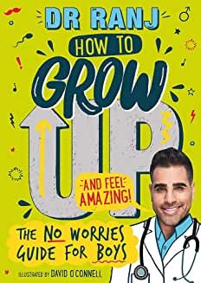

How to Grow Up and Feel Amazing!: The No-Worries Guide for Boys
by Dr. Ranj Singh and David O'Connell | 18 Feb 2021
https://www.amazon.co.uk/How-Grow-Feel-Amazing-No-Worries/dp/1526362953/ref=sr_1_51?adgrpid=107404667447&dchild=1&gclid=CjwKCAjw0qOIBhBhEiwAyvVcf2WEmX5mlf0JcllqH1cjUknRDNUfTy7UebKVMTIQiAvUlcpTpErbrxoCQpQQAvD_BwE&hvadid=445963430774&hvdev=c&hvlocphy=9045345&hvnetw=g&hvqmt=e&hvrand=13242499832230008205&hvtargid=kwd-825110760456&hydadcr=13716_1825022&keywords=mens+mental+health+books&qid=1627987369&sr=8-51



The Running Drug: How a running addiction helped one man overcome cancer, conquer a marathon and rediscover life
by Tim Beynon | 24 May 2021
https://www.amazon.co.uk/Running-Drug-addiction-overcome-rediscover/dp/1838465812/ref=sr_1_50?adgrpid=107404667447&dchild=1&gclid=CjwKCAjw0qOIBhBhEiwAyvVcf2WEmX5mlf0JcllqH1cjUknRDNUfTy7UebKVMTIQiAvUlcpTpErbrxoCQpQQAvD_BwE&hvadid=445963430774&hvdev=c&hvlocphy=9045345&hvnetw=g&hvqmt=e&hvrand=13242499832230008205&hvtargid=kwd-825110760456&hydadcr=13716_1825022&keywords=mens+mental+health+books&qid=1627987369&sr=8-50



Mandemic: A Tale of a Man Who Didn't Like to Be Told What to Do
by Natasha Jones | 29 Mar 2021

https://www.amazon.co.uk/Mandemic-Tale-Didnt-Like-Told/dp/1913206564/ref=sr_1_61?adgrpid=107404667447&dchild=1&gclid=CjwKCAjw0qOIBhBhEiwAyvVcf2WEmX5mlf0JcllqH1cjUknRDNUfTy7UebKVMTIQiAvUlcpTpErbrxoCQpQQAvD_BwE&hvadid=445963430774&hvdev=c&hvlocphy=9045345&hvnetw=g&hvqmt=e&hvrand=13242499832230008205&hvtargid=kwd-825110760456&hydadcr=13716_1825022&keywords=mens+mental+health+books&qid=1627987369&sr=8-61

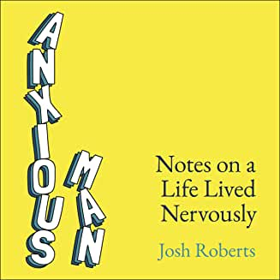

Anxious Man: Notes on a Life Lived Nervously
by Josh Roberts and Yellow Kite
https://www.amazon.co.uk/Anxious-Man-Notes-Lived-Nervously/dp/B083ZKB8XF/ref=sr_1_65?adgrpid=107404667447&dchild=1&gclid=CjwKCAjw0qOIBhBhEiwAyvVcf2WEmX5mlf0JcllqH1cjUknRDNUfTy7UebKVMTIQiAvUlcpTpErbrxoCQpQQAvD_BwE&hvadid=445963430774&hvdev=c&hvlocphy=9045345&hvnetw=g&hvqmt=e&hvrand=13242499832230008205&hvtargid=kwd-825110760456&hydadcr=13716_1825022&keywords=mens+mental+health+books&qid=1627987566&sr=8-65



Battle Scars
by Jason Fox and Penguin Audio
https://www.amazon.co.uk/Battle-Scars/dp/B07G8DXYZ5/ref=sr_1_66?adgrpid=107404667447&dchild=1&gclid=CjwKCAjw0qOIBhBhEiwAyvVcf2WEmX5mlf0JcllqH1cjUknRDNUfTy7UebKVMTIQiAvUlcpTpErbrxoCQpQQAvD_BwE&hvadid=445963430774&hvdev=c&hvlocphy=9045345&hvnetw=g&hvqmt=e&hvrand=13242499832230008205&hvtargid=kwd-825110760456&hydadcr=13716_1825022&keywords=mens+mental+health+books&qid=1627987566&sr=8-66



Men's Health: All you need to know in one concise manual Hardcover – 4 Sept. 2020
https://www.amazon.co.uk/Mens-Health-need-concise-manual/dp/1785216945/ref=sr_1_14?adgrpid=107404667447&dchild=1&gclid=CjwKCAjw0qOIBhBhEiwAyvVcf2WEmX5mlf0JcllqH1cjUknRDNUfTy7UebKVMTIQiAvUlcpTpErbrxoCQpQQAvD_BwE&hvadid=445963430774&hvdev=c&hvlocphy=9045345&hvnetw=g&hvqmt=e&hvrand=13242499832230008205&hvtargid=kwd-825110760456&hydadcr=13716_1825022&keywords=mens+mental+health+books&qid=1627986585&sr=8-14

